Reconciliation - Details vs TB

## Instructions

Instructions for “Reconciliation - Details vs TB”

**Please read and follow all the instructions for a proper use of the application!**

## Pre-requisites:

**Phase 1: Documents to be received:**

-Trial Balance as at Audit Period (excel .xlsx format)

-Account Details (excel .xlsx. format)

**Phase 2: Pre-requisites:**

**Trial Balance (TB):**

The headers of the Trial Balance (TB) file used for input should be renamed as follows:

|  |  |  |  |
| --- | --- | --- | --- |
| **Description as per PBC** | **New description of key headers** | **Format** | **Example** |
| OMF Account (Analytical): => | **Account** | General / Number | 1175  121.13 |
| Account Description: => | **Description** | General | Buildings / Licenses |
| Opening Balance: => | **OB** | Number | (12,462,161)  (2,406,271) |
| Debit Movement: => | **DM** | Number | 3,516,868  10,627,971 |
| Credit Movement: => | **CM** | Number | 3,649,699  162,134 |
| Closing Balance: => | **CB** | Number | 12,065,639  (5,712) |

**\*Note: TB should be closed before input; above columns refer to closed TB.**

**Account Details:**

The headers of the Details of Account files used for input should be renamed as follows:

|  |  |  |  |  |
| --- | --- | --- | --- | --- |
| **Description as per PBC** | **New description of key headers** | **Format** | **Example** | **Mandatory/**  **Non mandatory** |
| OMF Account: => | **Account** | General /Number | 205,211,214 | Mandatory |
| Date of Transaction: => | **Date** | Date | 24/05/2021 | Mandatory |
| Document Number:  => | **Document Number** | General /Number | 100456 | Mandatory |
| Amount in foreign currency: => | **Amount in FX** | Number | 10,002,401 | Non-mandatory |
| Amount: => | **Amount** | Number | 10,002,401 | Mandatory |
| Description of Transaction:  => | **Description** | General / Text | Buildings | Mandatory |
| Partner Name: => | **Partner Name** | General / Text | SC. ABC SRL | Non-mandatory |
| Currency: => | **Currency** | General / Text | RON/EUR | Non-mandatory |

**General notes:**

1. It is mandatory that the PBC contains the column headers presented above, but it is not mandatory to contain data beneath
2. It is not mandatory for the headers to be on the first row, or columns in any specific order
3. If any, all the data beneath the last rows of the PBC to be imported that are not relevant (i.e totals, other information) should be deleted, otherwise it will be imported in the application.
4. The application will import the first worksheet of each PBC- therefore the PBC needed to be uploaded should be moved first

## Instructions:

1. After connecting to the platform, go to **Reconciliation details with TB**:

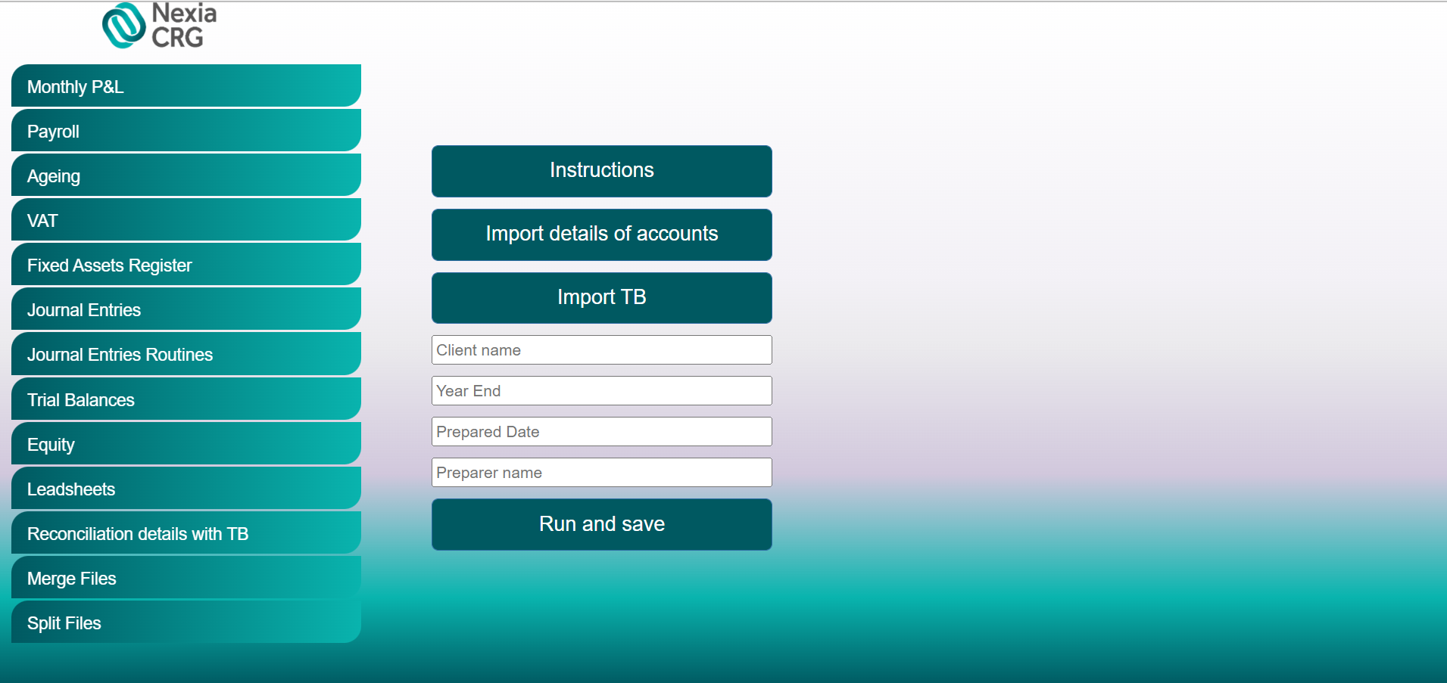

1. Click on “Import details of accounts” botton and import the Account Details;
2. Click on the “Import TB” botton and import the Trial Balance;
3. Enter the Client’s name, the period end (MM/DD/YYYY) of the audit (Year End), Prepared Date and Prepared name.
4. Click “Run and save”. Once clicking that, the robot will process your request and download the file in your designated downloads folder.
5. Finally, you should obtain an archive document named after the client.

For any issues, questions and/ or suggestions, please contact:

Cristian Iordache, [cristian.iordache@ro.gt.com](mailto:cristian.iordache@ro.gt.com)

Bogdan Constantinescu, [bogdan.constantinescu@ro.gt.com](mailto:bogdan.constantinescu@ro.gt.com)